UNITED STATES

SECURITIES AND EXCHANGE COMMISSION
WASHINGTON, DC 20549

SCHEDULE 14A

(Rule 14a-101)

SCHEDULE 14A INFORMATION

 | Proxy Statement Pursuant to Section 14(a) of the
 | Securities Exchange Act of 1934
 | (Amendment No. |  | )
Filed by the Registrant ☒ | Filed by a Party other than the Registrant |  | ☐
Check the appropriate box:

- Preliminary Proxy Statement

- Confidential, for use of the Commission Only (as permitted by Rule 14a-6(e)(2))

- Definitive Proxy Statement

- Definitive Additional Materials

- Soliciting Material under §240.14a-12

ACADIA HEALTHCARE COMPANY, INC.

(Name of Registrant as Specified in its Charter)

(Name of Person(s) Filing Proxy Statement, if other than the Registrant)

Payment of Filing Fee (Check the appropriate box):

- No fee required.

- Fee computed on table below per Exchange Act Rules 14a-6(i)(1) and 0-11.

  - Title of each class of securities to which transaction applies:

  - Aggregate number of securities to which transaction applies:

  - Per unit price or other underlying value of transaction computed pursuant to Exchange Act Rule 0-11 (set forth the amount on which the filing fee is calculated and state how it was determined):

  - Proposed maximum aggregate value of transaction:

  - Total fee paid:

- Fee paid previously with preliminary materials.

- Check box if any part of the fee is offset as provided by Exchange Act Rule 0-11(a)(2) and identify the filing for which the offsetting fee was paid previously. Identify the previous filing by registration statement number, or the form or schedule and the date of its filing.

  - Amount previously paid:

- Form, Schedule or Registration Statement No.:

- Filing party:

- Date filed:

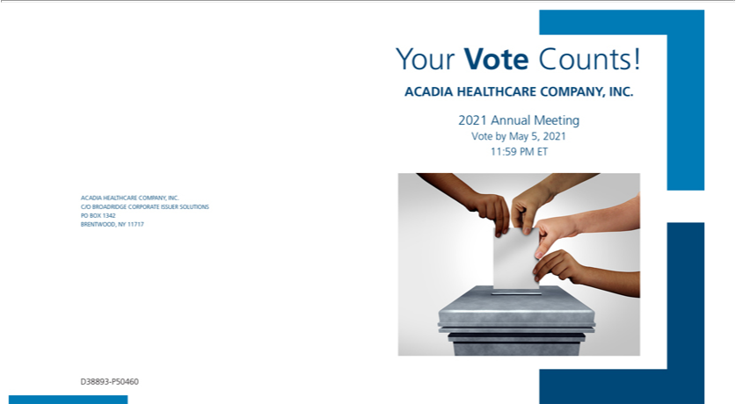

You invested in ACADIA HEALTHCARE COMPANY, INC. and it’s time to vote!

You have the right to vote on proposals being presented at the Annual Meeting. This is an important notice regarding the availability of proxy materials for the stockholder meeting to be held on May 6, 2021.

Get informed before you vote

View the Notice and Proxy Statement and Annual Report online OR you can receive a free paper or email copy of the materials by requesting prior to April 22, 2021. If you would like to request a copy of the materials for this and/or future shareholder meetings, you may

- visit www.proxyvote.com, (2) call 1-800-579-1639 or (3) send an email to sendmaterial@proxyvote.com. If sending an email, please include your control number (indicated below) in the subject line. Unless requested, you will not otherwise receive a paper or email copy.


Smartphone users |  | Vote Virtually at the Meeting*
Point your camera here and |  | May 6, 2021
Point your camera here and |  | 9:00 a.m. (Central Time)
vote without entering a
control number
 |  | Virtually at:
 |  | www.virtualshareholdermeeting.com/ACHC2021



*Many stockholder meetings have attendance requirements including, but not limited to, the possession of an attendance ticket issued by the entity holding the
meeting. Please check the meeting materials for any special requirements for meeting attendance. | V1

Vote at www.proxyvote.com

THIS IS NOT A VOTABLE BALLOT

This is an overview of the proposals being presented at the

upcoming stockholder meeting. Please follow the instructions on

the reverse side to vote on these important matters.

 |  | Board
Voting Items |  | Recommends
1. | Election of Directors
 | Nominees:
1a. | E. Perot Bissell | For
1b. | Vicky B. Gregg | For
1c. | Debra K. Osteen | For
2. | Approve an amendment to the Acadia Healthcare Company, Inc. Incentive Compensation Plan. | For
3. | Advisory vote on the compensation of the Company’s named executive officers as presented in the Proxy Statement. | For
4. | Ratify the appointment of Ernst & Young LLP as the Company’s independent registered public accounting firm for the | For
 | fiscal year ending December 31, 2021.


NOTE: In their discretion, the proxies are authorized to vote upon such other business as may properly come before the meeting or any adjournment thereof.

Prefer to receive an email instead? While voting on www.proxyvote.com, be sure to click “Sign up for E-delivery”.

D38894-P50460

